**Draft Results of EDF Country Rankings**

These results summarize the current state, trajectory, and future status fisheries of selected countries.

*Key Caveats*

* These only include “overfished” fisheries (current biomass less than Bmsy)
* Only finfish, and only fisheries identified to the genus-species level
* I have removed small pelagic species from this analysis. This is following discussions with Ray and Trevor regarding the fact that these species are unlikely to have true reference points like MSY. Since these small fisheries are often the largest targeted by a country, it seems disingenuous to base yield projections on the hope of reforming small pelagics.
* Optimization is over a 30-year time horizon. Some fisheries are not able to recover over this time, resulting in B/Bmsy <1.

*Results*

* All selected countries except Indonesia have potential to increase yields and biomass by reforming overfished stocks
* The optimal control policy calls for steep drops in yields over the next 5-10 years
* The ROI is substantial for most countries evaluated, though the US and EU are the largest. However, this is likely due to the sample size; many large fisheries are not included in Peru and Indonesia.
* The median ROI is much higher for Peru and Indonesia, hard to really say much about this except that rankings/interest really depend a lot on how you want to measure things

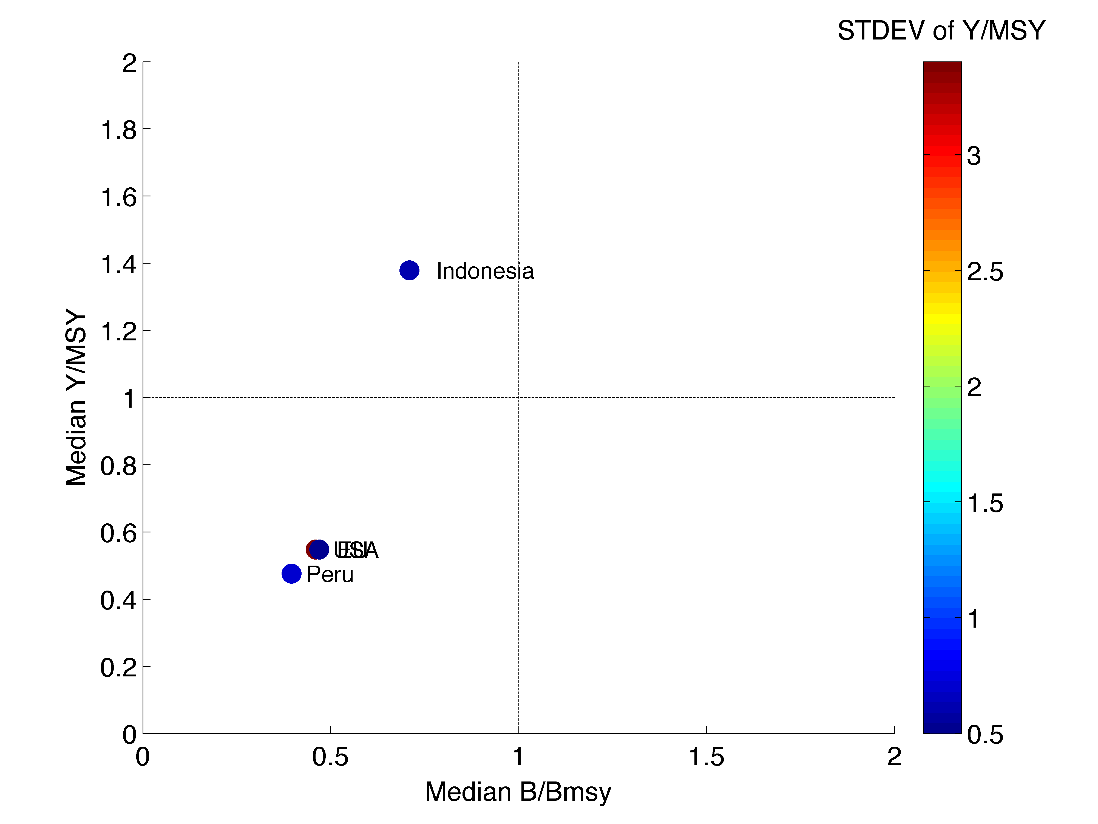

*Figure.2 Kobe plot of future yield over MSY and B/Bmsy under the status quo . Color is scaled by standard deviation of the Y/MSY f each fishery in a country*

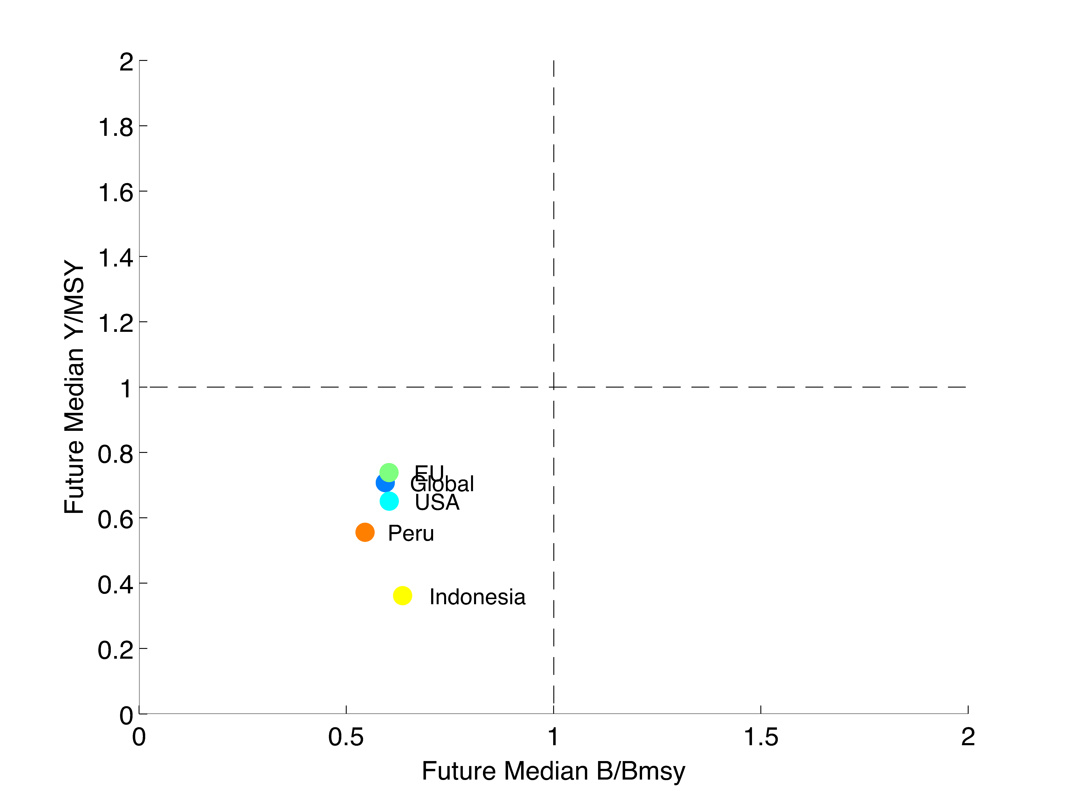

*Figure.1 Kobe plot of median current yield over MSY and B/Bmsy. Color is scaled by standard deviation of the Y/MSY f each fishery in a country*

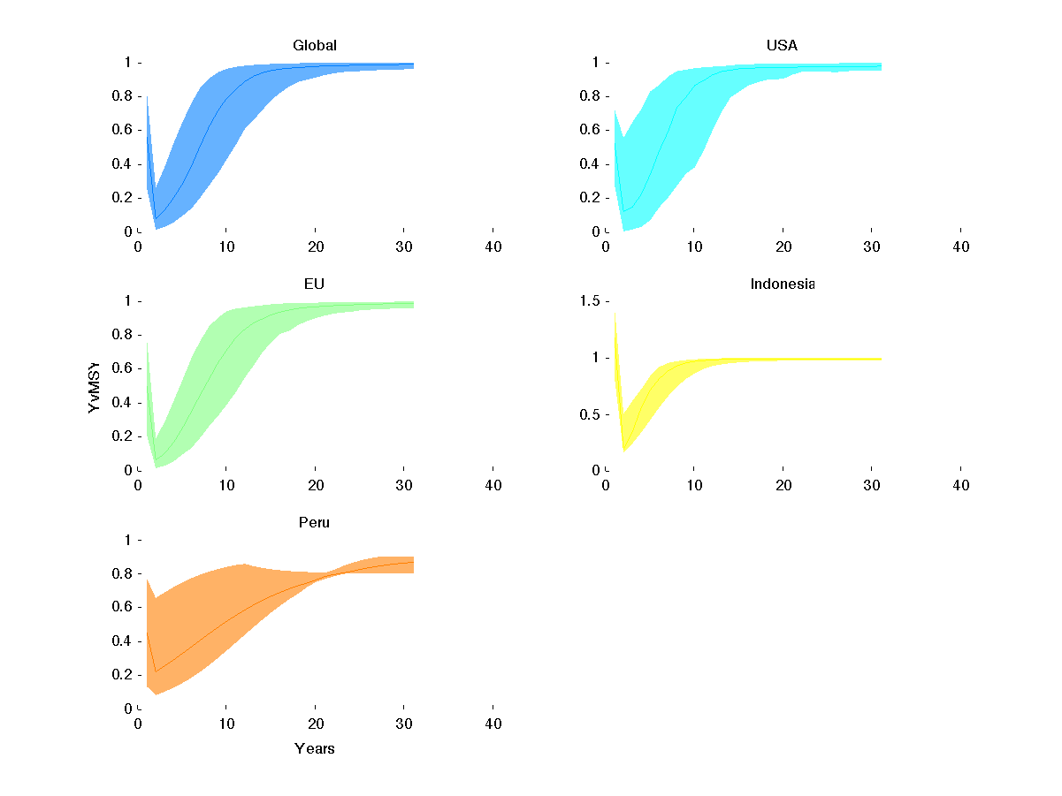

*Figure 3. Trajectory of Y/Ymsy under optimal management over time. Dark line is the median, shaded region indicates the interquantile range*

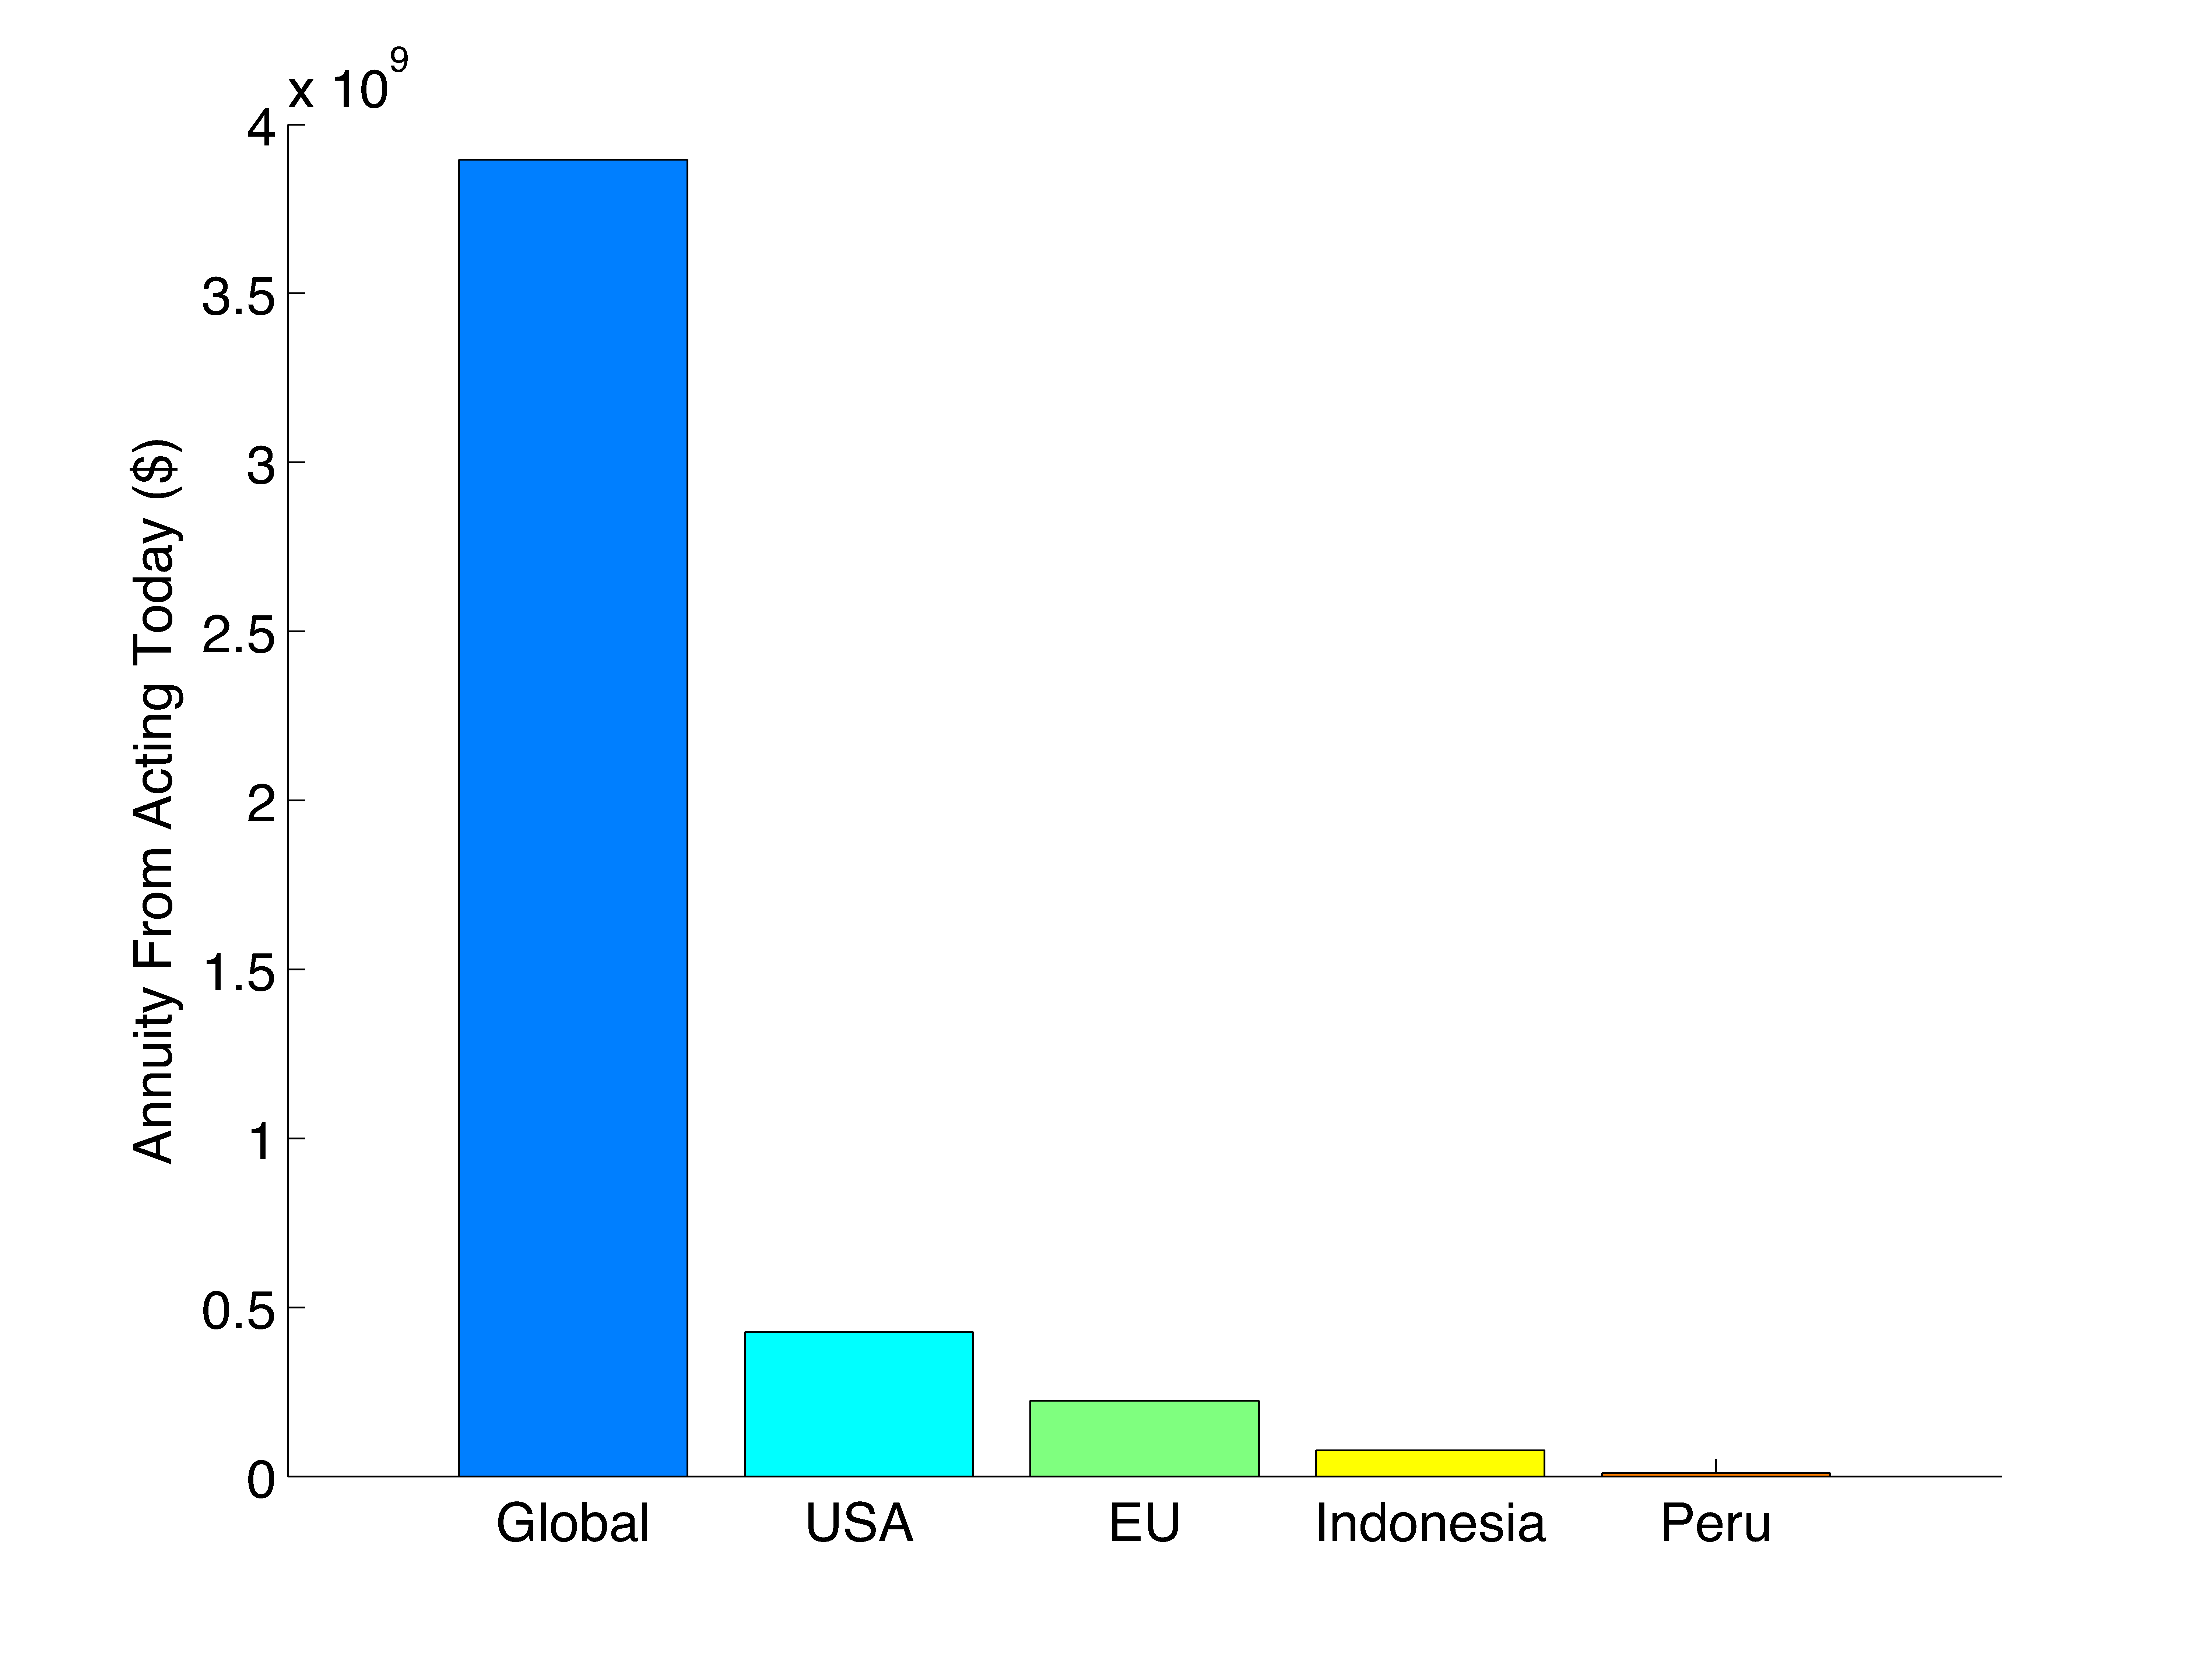

*Figure 4. Total annuity from reforming fisheries today, relative to the status quo*

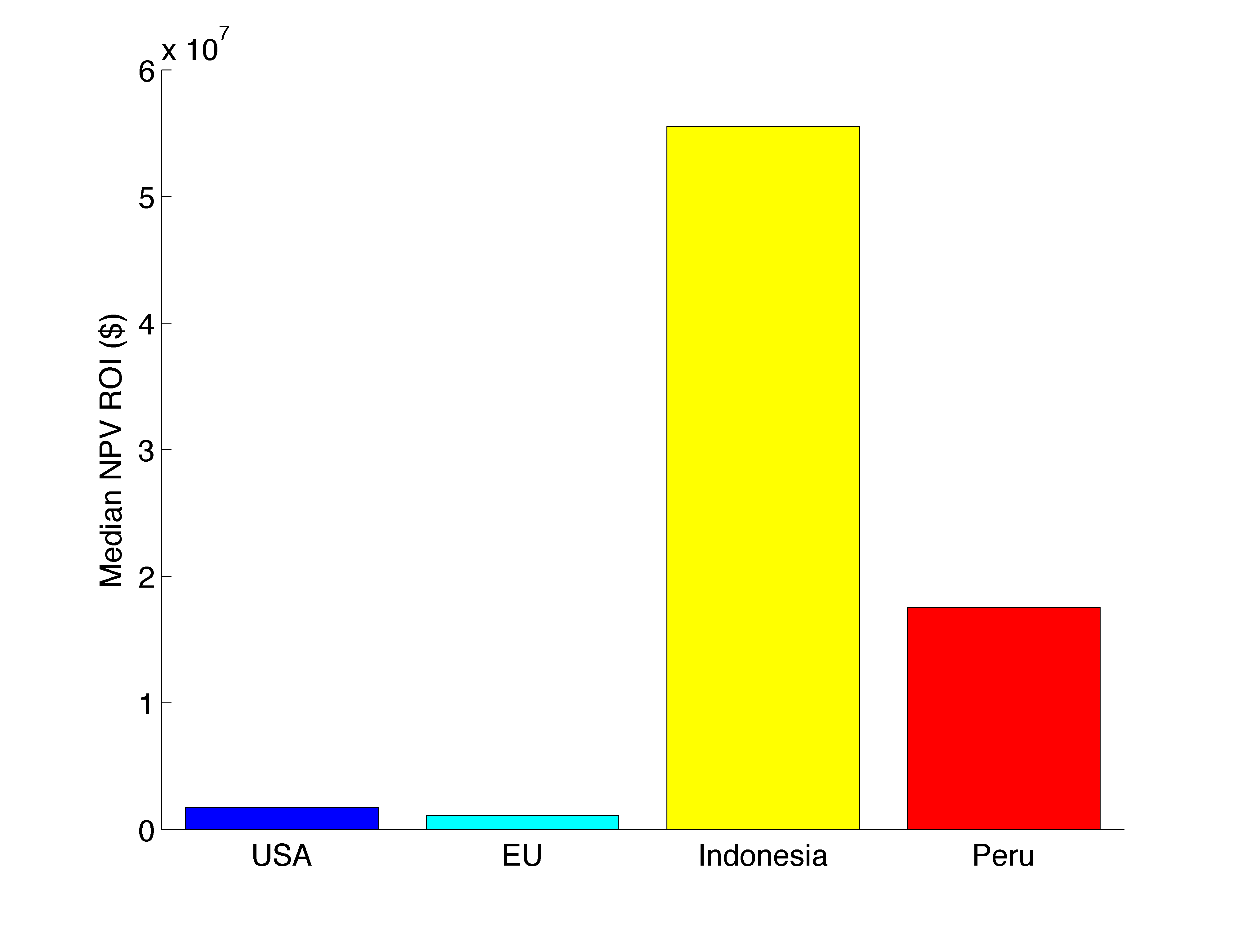

Figure.5 Total NPV ROI for each country of interest

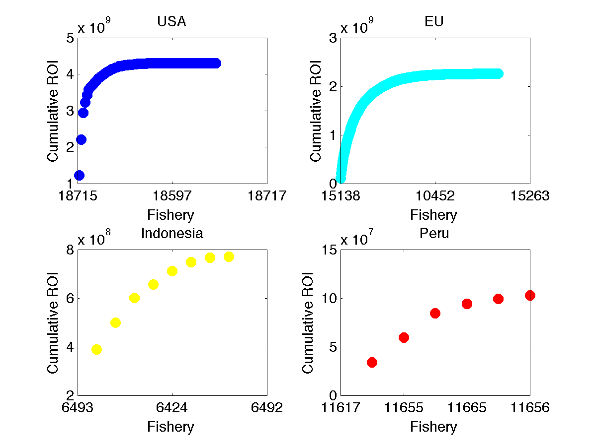

Figure 6. Cumulative distribution of each country’s ROI

Table 1. **Very** rough approximation of % of fisheries (species+country+FAO Region) and total catch reported in 2011 by the FAO for each country. Note that this includes stocks caught by a country outside of its EEZ; as such these numbers are too low

|  |  |  |
| --- | --- | --- |
| Country | % of Fisheries | % of Catch |
| United States of America | 16% | 9% |
| Japan | 14% | 77% |
| China | 2% | 3% |
| Indonesia | 3% | 3% |
| Argentina | 17% | 44% |
| Taiwan Province of China | 7% | 7% |
| Brazil | 8% | 9% |
| India | 3% | 1% |
| Iran (Islamic Rep. of) | 21% | 5% |
| Nigeria | 10% | 5% |
| Thailand | 9% | 1% |
| Chile | 12% | 0% |
| Canada | 9% | 2% |
| Ghana | 11% | 9% |
| Ukraine | 17% | 9% |
| Australia | 11% | 6% |
| Philippines | 5% | 1% |
| Peru | 10% | 0% |
| Uruguay | 40% | 12% |
| Senegal | 11% | 4% |
| New Zealand | 11% | 3% |
| Malaysia | 5% | 1% |
| Turkey | 13% | 2% |
| Tunisia | 22% | 12% |
| Mexico | 5% | 0% |
| Morocco | 6% | 1% |
| Pakistan | 13% | 1% |
| Cuba | 21% | 9% |
| Gambia | 30% | 18% |
| Namibia | 12% | 0% |
| South Africa | 9% | 19% |
| United Arab Emirates | 3% | 8% |
| Iceland | 11% | 0% |
| Faroe Islands | 12% | 1% |
| Egypt | 3% | 1% |
| Saudi Arabia | 6% | 3% |
| Costa Rica | 150% | 36333% |
| Dominican Republic | 9% | 3% |
| Qatar | 7% | 5% |
| Colombia | 7% | 0% |
| Yemen | 6% | 0% |
| Kiribati | 12% | 0% |
| Albania | 6% | 8% |
| Norway | 5% | 0% |
| Bahamas | 8% | 2% |
| Mauritania | 1% | 0% |
| Singapore | 14% | 4% |
| Mauritius | 4% | 10% |
| Algeria | 2% | 0% |
| Belize | 1% | 0% |
| Puerto Rico | 12% | 15% |
| Channel Islands | 26% | 6% |
| Israel | 29% | 35% |
| Benin | 2% | 0% |
| Togo | 13% | 0% |
| Seychelles | 2% | 0% |
| Greenland | 4% | 0% |
| Eritrea | 8% | 2% |
| Sao Tome and Principe | 17% | 3% |
| Isle of Man | 38% | 0% |
| Falkland Is.(Malvinas) | 4% | 0% |
| St. Pierre and Miquelon | 22% | 0% |
| Palau | 14% | 1% |